Application Exercise 1A: Noun Description

Circle the compound nouns on this list. Beside each word, write M (masculine), F (feminine), I (indefinite), or N (neutral).
Identify the form and class characteristics of each noun by checking any box that applies.

 |  | FORM |  | CLASS
1. | baggage | Singular | Plural | Common | Proper | Count | Noncount | Collective | Concrete | Abstract
2. | Black Beauty | Singular | Plural | Common | Proper | Count | Noncount | Collective | Concrete | Abstract
3. | blues | Singular | Plural | Common | Proper | Count | Noncount | Collective | Concrete | Abstract
4. | brothers | Singular | Plural | Common | Proper | Count | Noncount | Collective | Concrete | Abstract
5. | camera | Singular | Plural | Common | Proper | Count | Noncount | Collective | Concrete | Abstract
6. | cement | Singular | Plural | Common | Proper | Count | Noncount | Collective | Concrete | Abstract
7. | committee | Singular | Plural | Common | Proper | Count | Noncount | Collective | Concrete | Abstract
8. | cotton | Singular | Plural | Common | Proper | Count | Noncount | Collective | Concrete | Abstract
9. | data | Singular | Plural | Common | Proper | Count | Noncount | Collective | Concrete | Abstract
10. | deer | Singular | Plural | Common | Proper | Count | Noncount | Collective | Concrete | Abstract
11. | dentist | Singular | Plural | Common | Proper | Count | Noncount | Collective | Concrete | Abstract
12. | fortitude | Singular | Plural | Common | Proper | Count | Noncount | Collective | Concrete | Abstract
13. | geometry | Singular | Plural | Common | Proper | Count | Noncount | Collective | Concrete | Abstract
14. | Grateful Dead | Singular | Plural | Common | Proper | Count | Noncount | Collective | Concrete | Abstract
15. | herd | Singular | Plural | Common | Proper | Count | Noncount | Collective | Concrete | Abstract
16. | men | Singular | Plural | Common | Proper | Count | Noncount | Collective | Concrete | Abstract
17. | mist | Singular | Plural | Common | Proper | Count | Noncount | Collective | Concrete | Abstract
18. | neighborhoods | Singular | Plural | Common | Proper | Count | Noncount | Collective | Concrete | Abstract
19. | stability | Singular | Plural | Common | Proper | Count | Noncount | Collective | Concrete | Abstract
20. | symmetry | Singular | Plural | Common | Proper | Count | Noncount | Collective | Concrete | Abstract
Application Exercise 1B: Proportion of Nouns

The Speech-Language Pathologist (SLP) and Robby (a five-year-old boy with a language disorder) are using a book in a vocabulary-building exercise. As you read the following transcript representing their interaction . . .

1) Circle each noun used by Robby.

Speech-Language Pathologist | Robby
Do you know what that’s called? An iron. | A iron.
What are those? | A spider and a spider and a spider and a spider.
What’s that? | A apple.
What color is the apple? | Red.
How does it taste? Is it sweet or sour? | Sweet.
Sweet. Very good. | It’s for pirates! What is it?
An anchor. | A anchor.
Can you tell me something you see? | It’s red.
Ok, it’s red. What do you see on top of it? | It’s a triangle.
You throw it in the air. It’s called an arrow. | Arrow. A ant. It’s purple.

2) Determine the proportion of words that are nouns in comparison to all the other types of words Robby produced.
- Count the total number of nouns used and write it in the blank below.
- Count the total number of words produced and write it in the blank below.
- Divide the total number nouns used by the total number of words produced.
- Multiply this total by 100 to obtain the percent of nouns Robby used.
Calculating the Proportion of Nouns
__________ ÷ __________ = __________ x 100 = __________% Nouns

Total number of nouns
Total number of words

3) What proportion of nouns would you expect for a child of Robby’s age? __________

4) Now write a statement that characterizes the types of nouns present in Robby’s conversational language.

__________________________________________________________________________________________________________________________________________________________________________________________________________________________
Application Exercise 2A: Pronoun Description

Identify each underlined pronoun as one of the following types: Personal Nominative (PN), Personal Objective (PO), Personal Possessive (PP), Personal Reflexive (PR), Demonstrative (D), Indefinite (ID), Relative (RL), or Interrogative (IR).

 | 1. | She told us to clean it ourselves.
 | 2. | I wish he would tell us if he is coming.
 | 3. | Janie doesn’t think that anybody is going to do it.
 | 4. | The cat acts like the dog’s bone is hers.
 | 5. | Don’t throw those away.
 | 6. | They swore everyone to secrecy.
 | 7. | Even after they sprayed, the swarm came back to its hive.
 | 8. | The psychologist warned him about too much stress.
 | 9. | 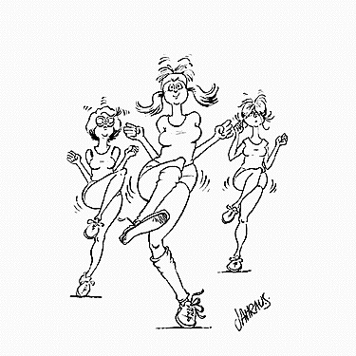  Those don’t look much different than diamonds.
 | 10. | Why don’t you think that behavior is inappropriate?
 | 11. | These have got to go!
 | 12. | The women who are known as “Jack’s girls” were roommates in college.
 | 13. | Will you please bring me the shortbread cookies?
 | 14. | Becky did not enjoy the movie as much as we did.
 | 15. | There is nothing I like more than sipping sweet tea.
 | 16. | Something has got to give!
 | 17. | That is Julia’s favorite book.
 | 18. | Carol is going to the beach by herself.
 | 19. | Why in the world did he go to Antarctica?
 | 20. | Yours is the one next to mine.

Application Exercise 2B: Pronoun Error Identification

Assume that the following samples are indicative of children’s typical pronoun usage in spontaneous speech. Indicate the type of pronoun each appears to be struggling with.

- her is little | ________________________________________________
- he wants to do it by hisself | ________________________________________________
- me like to buy chocolate if me go to the store | ________________________________________________
- them bears are scary looking! [pointing across room] | ________________________________________________
- Josh is putting the pencil in Josh’s book bag | ________________________________________________
- Kelly and I, us went to the mall | ________________________________________________

Use the space below to jot down any notes to yourself regarding how you might improve your assessment and/or intervention in this area.

Application Exercise 3A: Verb Description

Identify each underlined verb as one of the following: Copula be (C), Auxiliary be (A), Gerund (G), or Infinitive (I).

__________ | 1. | People don’t like to eat bones.
__________ | 2. | 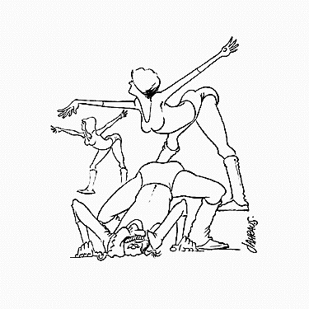  She was not coming until we asked her.
__________ | 3. | It is uncertain whether the wedding day will be sunny.
__________ | 4. | He is sure my condition will not improve.
__________ | 5. | You need to focus on keeping it warm.
__________ | 6. | To eat to my heart’s content is my plan for the day.
__________ | 7. | The truck driver slammed the door and swore never to return.
__________ | 8. | They were not happy about having to take care of the bill.
__________ | 9. | Purchasing the ring made her forget about what was to come.
__________ | 10. | Tell him that anxiety is a natural phenomenon.

Application Exercise 3B: Verb Conjugation (optional)

Conjugate the verbs talk and grow in the first person singular tense.

 |  |  | talk |  |  |  | grow
1. | Simple Present | I |  | . |  | I |  | .
2. | Simple Past | I |  | . |  | I |  | .
3. | Simple Future | I |  | . |  | I |  | .
4. | Present progressive | I |  | . |  | I |  | .
5. | Past progressive | I |  | . |  | I |  | .
6. | Future progressive | I |  | . |  | I |  | .
7. | Present perfect | I |  | . |  | I |  | .
8. | Past perfect | I |  | . |  | I |  | .
9. | Future perfect | I |  | . |  | I |  | .
Application Exercise 3C: Verb Analysis

A parent and her 4-year-old child are sharing a book during reading time. As you read the following transcript representing their interaction . . .

1) Circle each verb that occurs in the child’s utterances.

Parent | Child
I want to know why there are bones on it. | Oh, because dogs like bones.
[read from book] | But the mouse helped, the mouse helped by putting the shell in.
He sure did. | I don’t know why the dogs thought it was delicious. It had shells in it.
Because dogs are silly. | Yeah. And dogs don’t like the same things that people like.
They like different things. | Yeah.
Like bones. | We only like bones with chicken on them.
And chicken and what else? | We like to eat some things that are off bones, like chicken.
Yeah. | I like chicken off bones. Like drumsticks.

2) Examine the child utterances and determine if there are any examples of the following verb forms. If so, list one or two examples for each. If no examples occur for a particular category, write None.

- Simple Present tense verb
- Simple Past tense verb
- Simple Future tense verb
- Infinitive
- Gerund
- Auxiliary
- Contractible copular be
- Uncontractible copular be
Application Exercise 4: Adjective Description

Circle all the adjectives in each sentence, then identify each adjective as one of the following: Attributive (A), Predicate (Pd), Proper (Pp), Possessive (Ps), Demonstrative (Dem), Cardinal (C), Ordinal (O), Indefinite (Id), Interrogative (I?), Definite Article (DA), Indefinite Article (IA), or Noun Used As (NU).

 | 1. | That boy on my soccer team is a fast runner. (5)
 | 2. | Her little friend looks angry. (3)
 | 3. | Stacy’s sister was the first one to finish the long, difficult test. (6)
 | 4. | The new dentist will be with you shortly. (2)
 | 5. | It’s not an appropriate option for either one of you. (3)
 | 6. | What day are we going to that fancier Italian restaurant? (4)
 | 7. | I want this shade of blue on Josh’s bathroom walls. (3)
 | 8. | Support the homeless by donating to the brand new shelter. (4)
 | 9. | My mother will be eighty years old on her next birthday. (5)
 | 10. | Would you fix me a Jethro-size bowl of Fruit Loops cereal? (3)
 | 11. | A few stray cats have begun to fight every night around 10 o’clock. (4)
 | 12. | His favorite, Wayfarer sunglasses remained broken on the ground. (5)
 | 13. | Dad’s new Honda was only 12,000 dollars. (3)
 | 14. | Choir practice has been cancelled due to the excessive snowfall. (3)
 | 15. | Missy’s story was a fascinating account of her father’s life. (5)
 | 16. | Whose vase is the mint green? (3)
 | 17. | The 82nd airborne unit is located at the military base called Fort Bragg. (4)
 | 18. | Please call Jennifer’s mom about the used clothing. (3)
 | 19. | That other lady said she wanted which children’s book? (4)
 | 20. | Please keep your room organized and your trash emptied. (4)
Application Exercise 5A: Adverb Description

Identify each underlined adverb as one of the following: Manner (M), Place (P), Time, (T), Degree (D), Number (Nm), Reason (R), Affirmation (A), or Negation (Ng).

 | 1. | Yes, I never saw him.
 | 2. | I never had to take the GRE.
 | 3. | 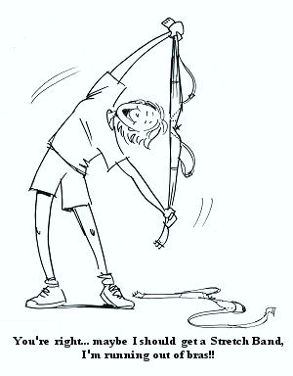  We carefully climbed down the cliff to reach the water
 | 4. | They were a good deal; consequently we bought them.
 | 5. | As soon as a James Taylor concert is announced, he’ll be in line.
 | 6. | She really knows what she’s talking about!
 | 7. | I have been looking all over for this!
 | 8. | This is the first opportunity I’ve had to relax.

Application Exercise 5B: Adverb or Conjunct

Identify each underlined word as either an Adverb (A) or an Adverbial Conjunct (AC).

 | 1. | Suddenly, she realized what she needed to do.
 | 2. | Before joining the circus, she was an accountant.
 | 3. | I run into him everywhere I go; in fact, I ran into him at the Gap.
 | 4. | Kesha is truly one of the sweetest children I know.
 | 5. | This torte is absolutely wonderful; likewise, the cake is delicious.
 | 6. | The power went out; consequently, I missed my morning class.
 | 7. | I’m not a proponent; rather, I’m an opponent.
 | 8. | I am really looking forward to Friday.

Application Exercise 6: Determiner Identification and Categorization

- Take a look at this brief story produced by a 6-year-old child. Underline all the determiners.

Once upon a time there was a little boy. His name was Bobby. Bobby told his friends to come over for a party. The kids came. Jamie, Scott, Annie, and some other kids too. They had a cake and some ice cream. And then Bobby’s dad helped them with some fireworks. Like firecrackers and those snakes in the grass. Then they opened the presents. Bobby didn’t know what present to open first. So he picked the biggest one. It was Jamie’s present. And it was another truck! Like the one his grandma gave him. So now he had two trucks! He loved this one. Then after the presents the kids went outside for more fireworks.

- Categorize the determiners you underlined above by writing each word in the appropriate column below.

Article | Possessive | Demonstrative | Quantifier | Wh- Word

- Use the chart above to characterize this child’s use of determiners. Write a brief descriptive sentence.

__________________________________________________________________________________________________________________________________________________________________________________________________________________________
Application Exercise 7: Conjunction Differentiation

In the following sentences, underline then identify each conjunction as either Coordinating (C) or Subordinating (S).

 | 1. | The child made a mess with the blocks and refused to clean them up.
 | 2. | Evolution is somewhat controversial, although it is still taught in many schools.
 | 3. | She received her certification; then, she began to pursue her Ph.D.
 | 4. | Autism has long been considered a functional disorder, but it likely has an organic cause.
 | 5. | He was told to prepare dinner while she finished the floral arrangements.
 | 6. | Jason was subtle, but it was clear to everyone why he was visiting.
 | 7. | Why he declined the invitation, Chad did not say.
 | 8. | The plan was to meet for dessert after the play was over.
 | 9. | Judy did not win first place, yet she still felt like a victor.
 | 10. | The clinician did not complete the evaluation; however, she felt it was imperative that treatment commence.

Use the space below to jot down any notes to yourself regarding how you might improve your assessment and/or intervention in this, or any, area previously reviewed.

Application Exercise 8A: Prepositional Verbs

Underline the prepositional verbs in each of the following sentences.

1. | The professor picks on the students who don’t attend. | 6. | Marcy told the teacher she is planning to drop out of school.
2. | Billy has been scolded for always shouting out the answer. | 7. | It is important to look out for deer on the highway.
3. | You will need to look that word up in the dictionary. | 8. | Please look after my mother while I am gone.
4. | Tommy can find out the answer on the Internet. | 9. | Sally said she would point the man out.
5. | Tell the children to put their coats on before we leave. | 10. | Please do not give away the saucers that my aunt left me.

Application Exercise 8B: Prepositional Phrases

- Consider the following story about a child’s vacation. Underline each prepositional phrase.

We were driving in our car. My mom was driving. We went into a big underground tunnel. My mom said it was two miles long. People turned on their lights in the tunnel. We were going to the beach in Virginia. When we were at the middle of the tunnel, there was an accident just ahead. I guess a van had run out of gas, and this semitruck ran into it. Anyway, we sat there for three hours, and my dad told us stories about his childhood. It was really boring, but I liked hearing about my dad.

- Review each prepositional phrase in the above narrative, and complete the following chart.

Simple Preposition | Article(s)/Adjective(s) | Object of Preposition

Application Exercise 10A: Noun Phrase Function

Indicate whether the underlined noun phrase in each sentence is the Subject (S), Object (O), Complement (C), or an Adverbial (ADV).

 | 1. | 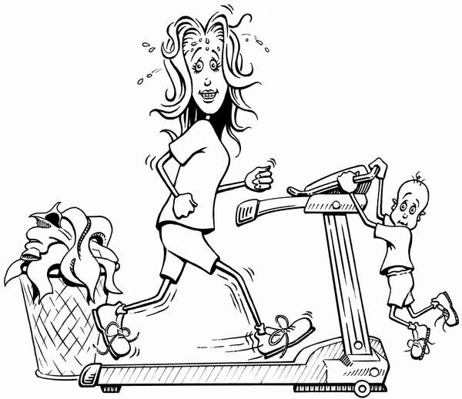  I am the speech-language pathologist.
 | 2. | You are not going out like that, are you?
 | 3. | Do that Thursday.
 | 4. | The little green hat will be perfect with that!
 | 5. | Don’t hit the counter with that.
 | 6. | We can always visit next month.
 | 7. | Don’t touch the hot wax!
 | 8. | He is my friend.

Application Exercise 10B: Phrase Differentiation

Indicate whether the underlined phrase in each sentence is a Noun Phrase (NP), Verb Phrase (VP), Prepositional Phrase (PP), Adjective Phrase (ADJP), or Adverb Phrase (ADVP).

 | 1. | Please drive carefully. |  | 8. | You need hot tea.
 | 2. | Jennifer will go with her. |  | 9. | His ideas are not very practical.
 | 3. | She is just gorgeous. |  | 10. | That dress is so pretty.
 | 4. | It’s going to be a nice day. |  | 11. | We will be calling on Friday.
 | 5. | She is driving me there. |  | 12. | Sid walked around the corner.
 | 6. | I just need more. |  | 13. | I swear I put it right there.
 | 7. | That old car will never make it. |  | 14. | The sun sets in the west.

Application Exercise 11A: Dependent Clause Identification

Offset the dependent clause in each of the following complex sentences by placing brackets around it.

1. | After Nancy gets here, we will meet you. | 6. | Still waiting for the results, we cancelled the reservations.
2. | Don’t tell them that it didn’t happen. | 7. | Unless the pediatrician calls, we’ll wait to write the report.
3. | The test she gave is not valid. | 8. | The team was late because the bus broke down.
4. | It sure is cold, although it is a nice break from the heat. | 9. | We are presenting today, as well as attending sessions.
5. | Wendy will do what her doctor says. | 10. | The professor will not share his formula, which is superb.

Application Exercise 11B: Relative Clause Identification

Place brackets around the relative clause embedded in each of the following sentences.

1. | The child she is concerned about was dismissed. | 6. | Complete the sections that are marked.
2. | The driver who held the bus for you got in trouble. | 7. | The toddler who was biting has now stopped.
3. | I told you that I can’t come. | 8. | The plans they shared with us are being implemented.
4. | Jennifer doesn’t know which one will be chosen. | 9. | The gala they weren’t invited to has been cancelled,
5. | Contact the doctor they recommended. | 10. | The horse that was so sick won’t be in the race.

Application Exercise 11C: T-unit Identification

A T-unit consists of an independent clause along with any dependent clauses. Place a slash (/) between T-units in this narrative.

The puppy went off on a walk by himself and he saw a little rabbit. The rabbit ran fast into the woods and the puppy chased him until he got tired. Then he sat down and he thought for a minute. He changed his mind and he decided to eat something. He looked around for stuff but he couldn’t find nothing. Then he saw his best friend, who is Max. And Max said he was having a party at his house. They went to Max’s and all the friends were there.
Application Exercise 12: Sentence Classification

Examine the following utterances produced by school-age children during speech-language intervention. Classify each sentence in terms of its clause structure: Simple (S), Compound (CP), Complex (CX), or Compound-Complex (CC). Then classify each sentence in terms of its function: Declarative (D), Imperative (Im), Exclamatory (E), or Interrogative (Ig).

Clause Structure |  | Function |  | BANG  HEAD  HERE
 |  |  | Richard: | Let’s read this one.
 |  |  | Richard: | I want to read this one.
 |  |  | Michelle: | You cut it.
 |  |  | Michelle: | We got French fries and we got hamburgers.
 |  |  | Teddy: | He’s not scary but he’s not nice.
 |  |  | Sandy: | She swimming in the water.
 |  |  | Sandy: | She swimming in the water and say “Help, help!”
 |  |  | Ricky: | It’s not my arm.
 |  |  | Ricky: | There my foot and there my arm.
 |  |  | Eric: | He got a ride.
 |  |  | Eric: | He got lots of things in his basket.
 |  |  | Roger: | That’s hooking together and flying over the park

